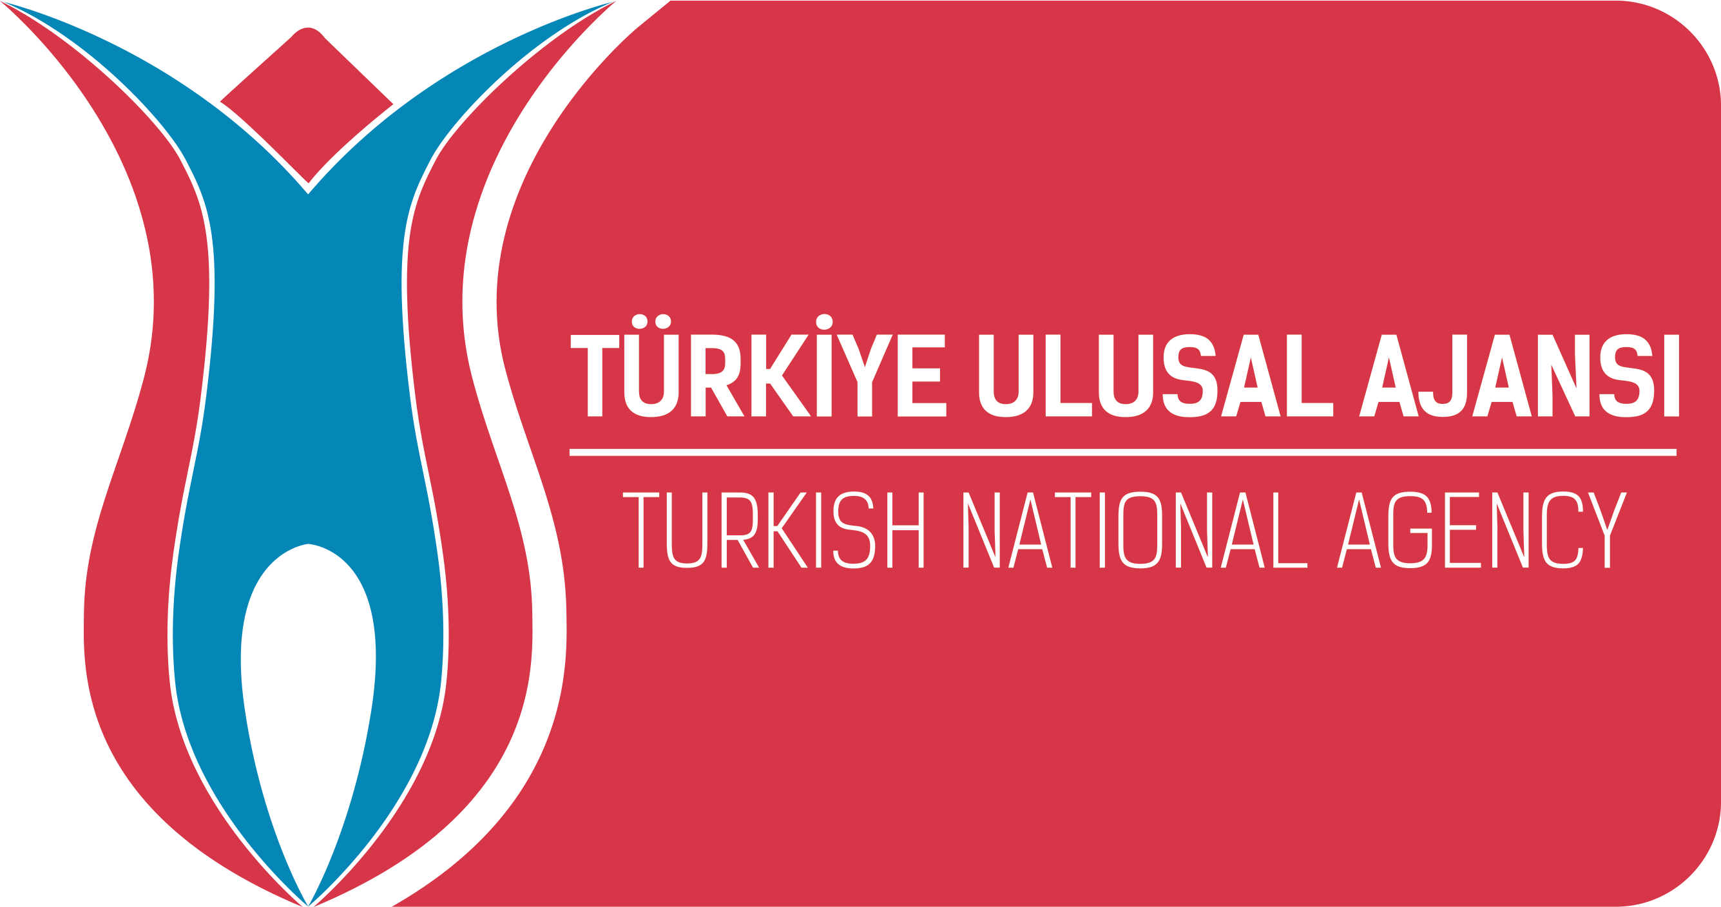
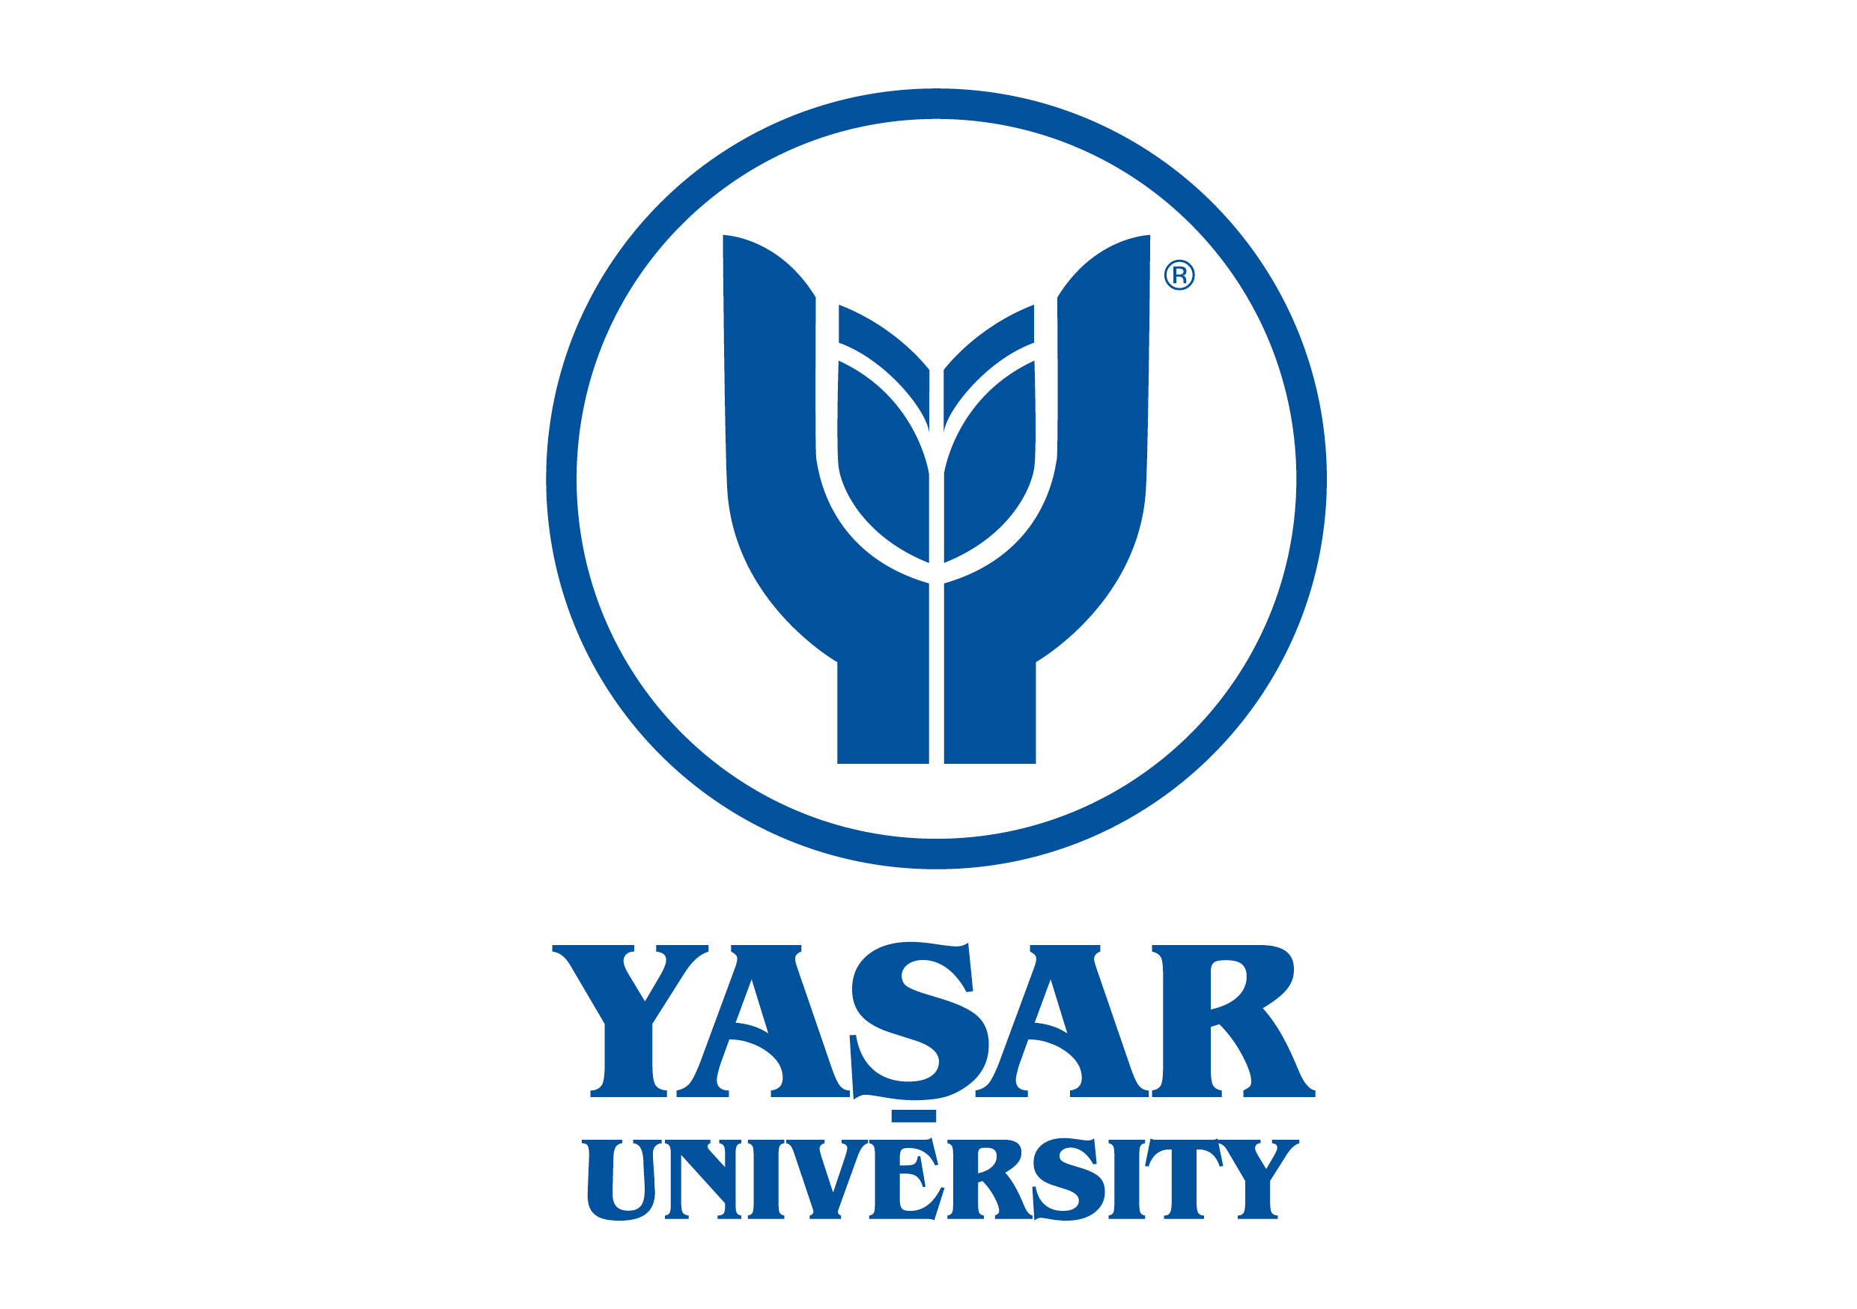
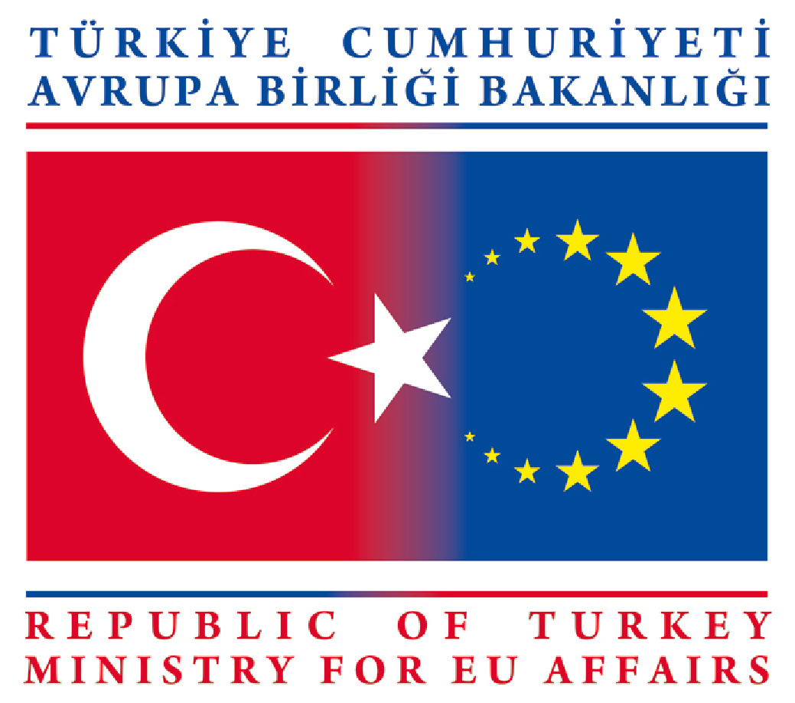
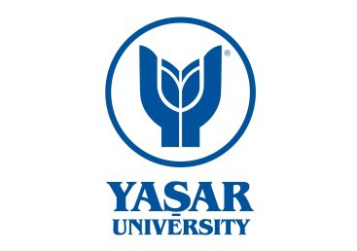

OMEGA PROJECT
“OPENING MORE EMPLOYMENT GATES FOR ARTS AND MUSIC STUDENTS”
ERASMUS INTENSIVE PROJECT
IZMIR, TURKEY
[5 April-16April 2016]
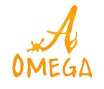

Attach Photo Here

Please return application form to burcu.kiper@yasar.edu.tr

You will receive a confirmation of receipt within 24 hours or on following working day.
If you do not receive this confirmation, you are asked to contact the same address.

Name & Surname
Gender (Male/Female)
Date of Birth (dd/mm/yy)
Email
Home Institution
Programme of Study

Please explain below, in under 250 words, why you would like to participate in the Omega Intensive Project.

